**Employee Management App implementation with Collections with Validation of Age**

1. **Initial Menu & View All**

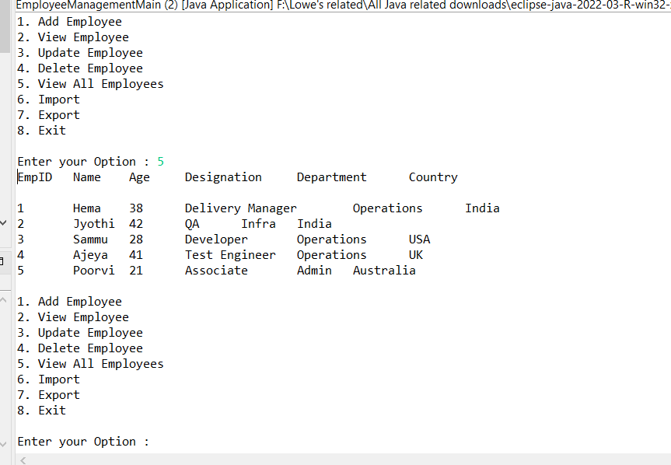

1. **Add Employee** option with **Age validation** until you enter right age, it pops up

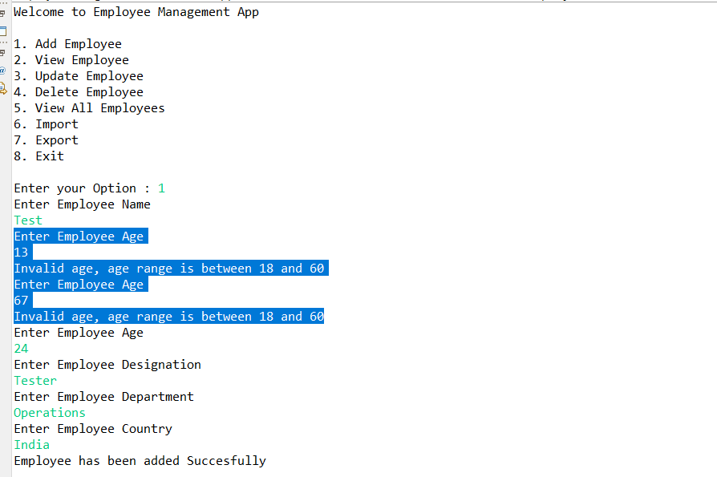

1. **Update an Employee**(with and without existing employee Id scenario)

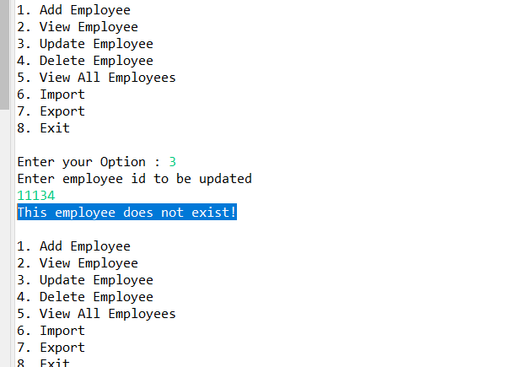

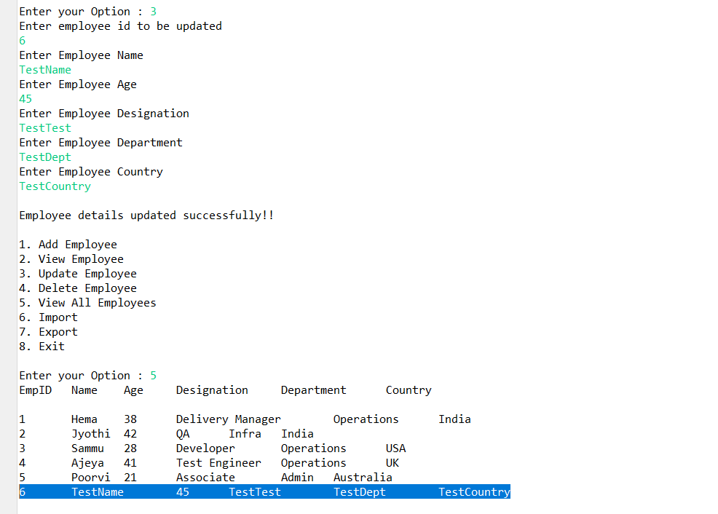

1. **View by employee ID** (the existing Id and without existing Id)

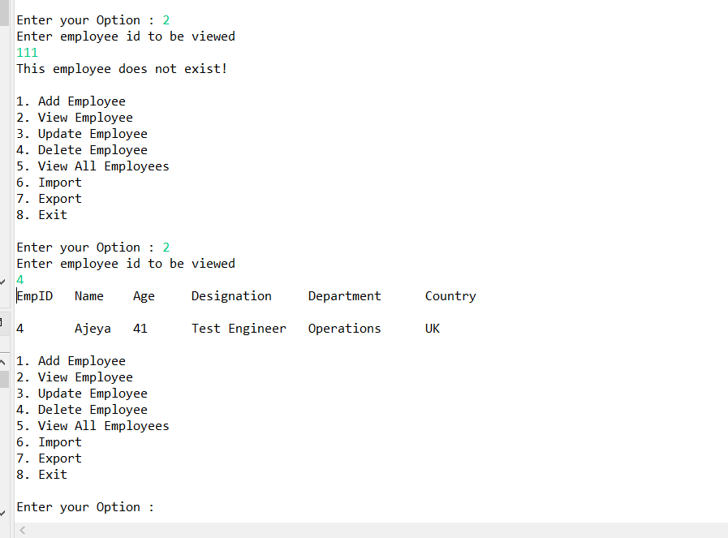

1. **Delete** an employee (by giving non existing n existing id )

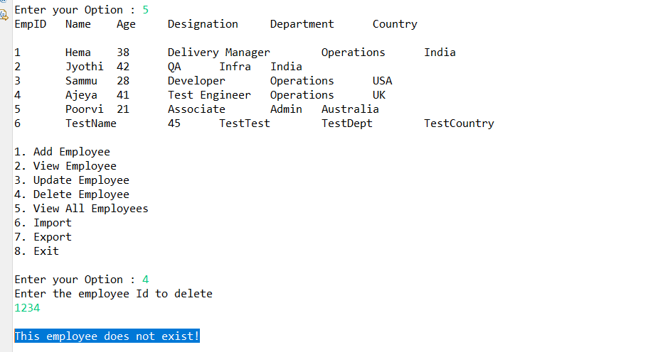

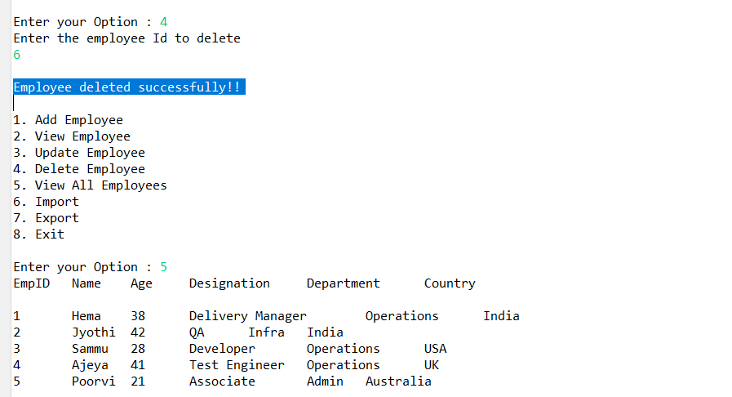

1. **Import** option

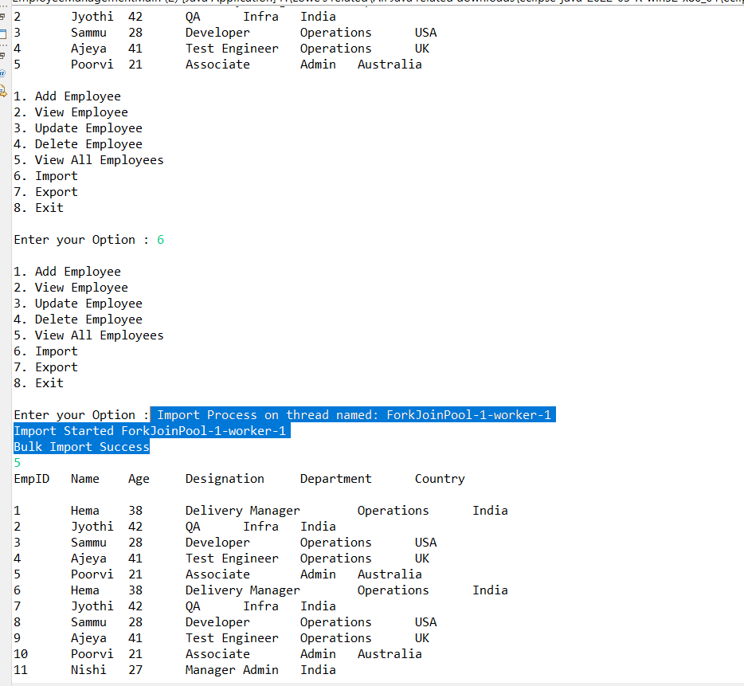

1. **Export** option

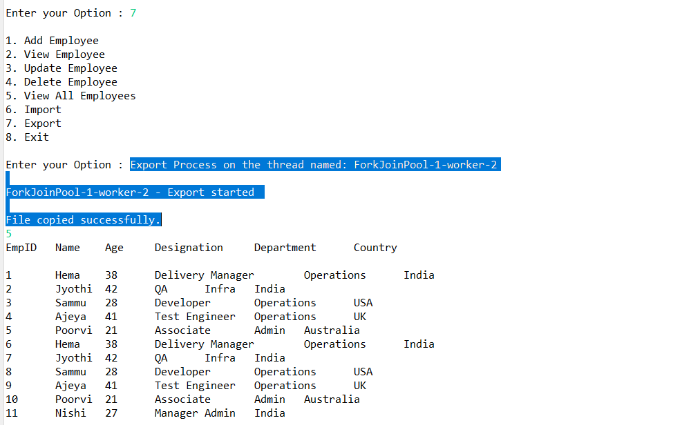

1. **Employee -output file snapshot after export Option**

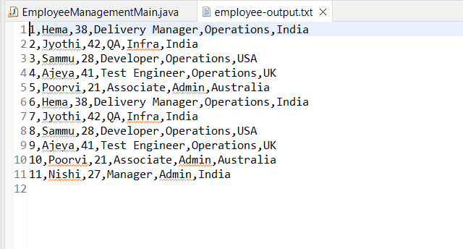

1. **Exit** option

